**Write a C program to arrange a series of numbers using Insertion Sort**

**INPUT:**

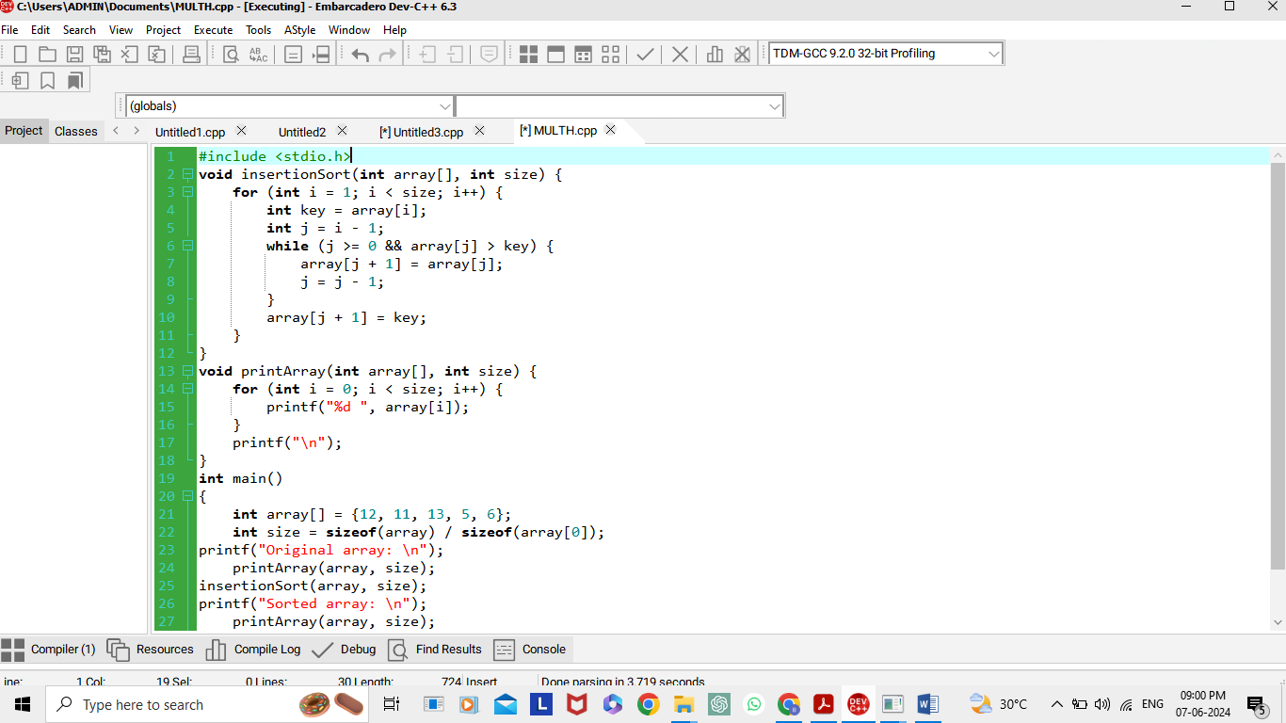

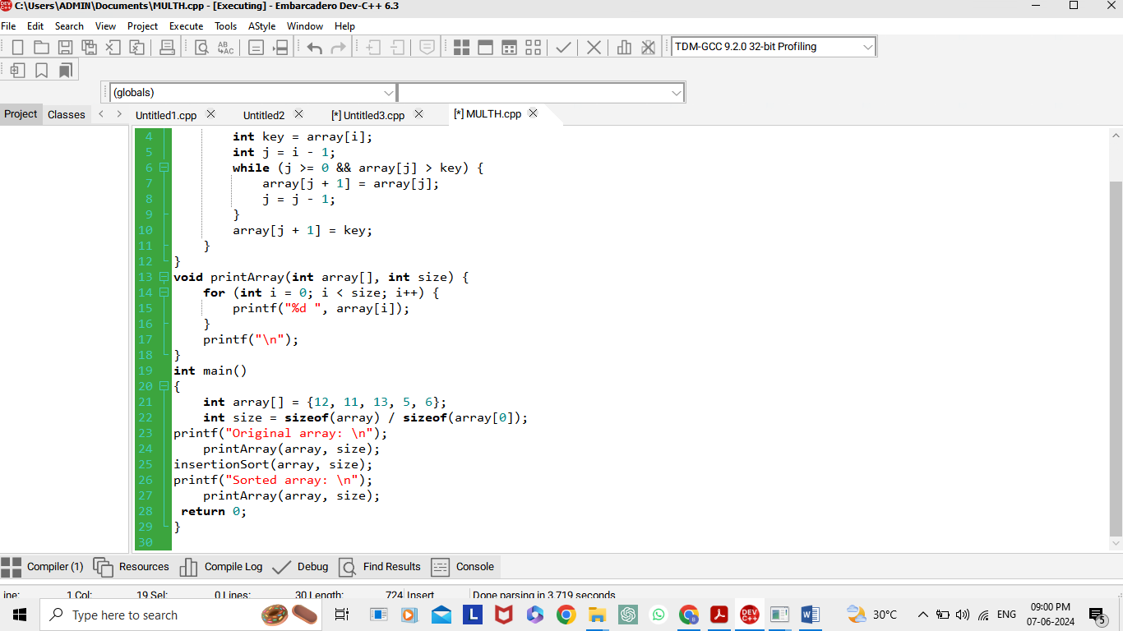

**OUTPUT:**

